**Unit I: FUNDAMENTALS OF IMAGE PROCESSING AND IMAGE TRANSFORMS**

Image processing is a field of computer science and engineering that focuses on analyzing, enhancing, and manipulating digital images. It involves the application of various techniques and algorithms to perform tasks such as image filtering, image restoration, image compression, object recognition, and more. Image processing has diverse applications, ranging from medical imaging and satellite imagery to entertainment and social media.

Image processing is a dynamic and interdisciplinary field that plays a vital role in various industries and applications. It involves the manipulation and analysis of digital images to extract valuable information, enhance visual quality, and facilitate decision-making processes. The widespread use of digital imaging devices, such as cameras and smartphones, has made image processing an integral part of modern technology.

**The primary** objective of image processing is to transform raw image data into more meaningful and useful representations. This transformation allows us to uncover hidden patterns, detect objects, recognize shapes, and perform other sophisticated tasks that benefit numerous domains.

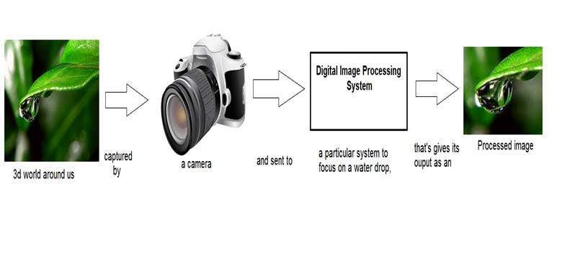

Here are some fundamental concepts in image processing:

**Digital Image:** A digital image is a 2D representation of visual information, composed of pixels (picture elements). Each pixel contains numerical values representing the color and intensity of a specific point in the image.

**Pixel:** A pixel is the smallest unit of a digital image. It is typically represented by a combination of red, green, and blue (RGB) values in color images or grayscale intensity in black and white images.

I**mage Processing Operations:** Image processing operations can be broadly categorized into two types: point processing and neighborhood processing. Point processing involves applying operations to individual pixels independently, while neighborhood processing applies operations to groups of pixels (e.g., by using filters).

**Image Transforms:** Image transforms are mathematical operations used to convert an image into a different domain or representation. Common image transforms include the Fourier transform, which decomposes an image into its frequency components, and the wavelet transform, which can analyze both frequency and spatial information simultaneously.

**Image Filtering:** Image filtering is a neighborhood processing operation that involves applying a filter or kernel to an image to perform operations like blurring, sharpening, edge detection, etc.

**Image Enhancement:** Image enhancement techniques aim to improve the visual quality of an image by increasing contrast, reducing noise, or enhancing specific features of interest.

**Image Compression:** Image compression is the process of reducing the size of an image to save storage space or transmit it efficiently. Lossless and lossy compression are the two main types of image compression techniques.

**Image Segmentation**: Image segmentation involves dividing an image into multiple segments or regions based on similarity criteria. It is commonly used for object recognition and scene analysis.

**Image Registration:** Image registration aligns two or more images taken at different times or from different viewpoints, enabling comparison or combination of the images.

**Morphological Operations**: Morphological operations are used to process image shapes using structuring elements. Erosion, dilation, opening, and closing are common morphological operations.

**Applications:**

The applications of image processing are extensive and continue to expand as technology advances. Some notable applications include:

**Medical Imaging:** In medical diagnosis, image processing aids in detecting tumors, analyzing X-rays, MRIs, and CT scans, and assisting in surgical planning.

**Biometrics:** Image processing is used in facial recognition, fingerprint identification, and other biometric systems for security and authentication purposes.

**Robotics and Autonomous Vehicles:** Image processing enables robots and self-driving cars to perceive and interact with their environment effectively.

**Remote Sensing:** Satellite and aerial imagery are processed to monitor environmental changes, assess crop health, and manage natural disasters.

**Entertainment and Multimedia:** Image processing is prevalent in video games, special effects in movies, and image editing software.

**Augmented Reality (AR) and Virtual Reality (VR):** Image processing enhances AR and VR experiences by blending digital elements with real-world imagery.

**Fundamental steps in image processing**

1. **Image Acquisition**: The first step in image processing is to capture or acquire the image using cameras, scanners, or other imaging devices. The quality and characteristics of the acquired image can significantly impact the subsequent processing steps.
2. **Image Pre-processing:** Pre-processing involves preparing the image for further analysis by applying various techniques to correct imperfections, reduce noise, and enhance the overall image quality. It includes tasks such as noise removal, image denoising, color correction, and contrast stretching.
3. **Image Sampling:** Image sampling is the process of converting a continuous-tone analog image into a discrete digital representation by selecting specific points (pixels) from the continuous image domain. Each pixel represents a specific location and contains information about the intensity or color of that point.
4. **Image Quantization:** After sampling, the next step is image quantization, which assigns digital values (intensity levels) to each pixel based on its sampled intensity value. For example, in an 8-bit image, each pixel can have one of 256 intensity levels, ranging from 0 (black) to 255 (white).
5. **Image Enhancement:** Image enhancement techniques are applied to improve the visual quality of the image, highlight specific features, or make it suitable for specific applications. Enhancements include contrast stretching, histogram equalization, and spatial filtering.
6. **Image Restoration**: Image restoration aims to improve images that have been degraded by factors like noise, blurring, or compression artifacts. Restoration techniques try to recover the original image by estimating and correcting the degradation effects.
7. **Image Transformation:** Image transformations are used to convert images into different domains to reveal specific information or features. For instance, the Fourier transform is used for frequency domain analysis, while the wavelet transform can capture both frequency and spatial information.
8. **Image Compression**: Image compression reduces the size of an image to save storage space and facilitate efficient transmission over networks. Lossless and lossy compression techniques are employed based on the application requirements.
9. **Image Segmentation:** Image segmentation divides an image into meaningful regions or objects. This step is crucial for object recognition, tracking, and further analysis.
10. **Object Detection and Recognition**: Object detection and recognition involve identifying specific objects or patterns within an image. This task is essential in applications like facial recognition, object tracking, and autonomous vehicles.
11. **Image Analysis and Interpretation:** Image analysis involves extracting meaningful information from the processed image, interpreting the results, and making decisions based on the analysis.
12. **Image Display and Visualization:** The final step involves displaying the processed image or its results in a visually understandable format for human interpretation and interaction.

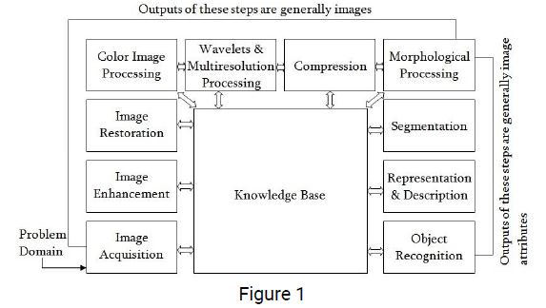

**Image sampling**

Image sampling is a crucial process in digital image processing that involves converting a continuous-tone analog image into a discrete digital representation. In other words, it is the process of converting a continuous image into a grid of discrete pixels, each representing a specific location and containing information about the intensity or color of that point.

**Sampling** is necessary to represent an image in digital form, enabling storage, processing, and display on digital systems like computers and screens. The process involves capturing samples of the continuous image at regular intervals along rows and columns to form a grid. Each sample corresponds to a pixel in the digital image.

The sampling process is defined by two main parameters:

1. **Sampling Rate (Spatial Resolution)**: The sampling rate determines how many samples (pixels) are taken per unit distance in the image. It is usually expressed in samples per inch (SPI) or pixels per inch (PPI) for printed images and dots per inch (DPI) for digital screens. A higher sampling rate (more pixels per inch) results in a higher spatial resolution, capturing more detail in the image.
2. **Sampling Interval:** The sampling interval is the distance between adjacent samples in the image. It is usually denoted by "Δx" and "Δy" for the horizontal and vertical directions, respectively. Smaller sampling intervals lead to a more detailed representation of the image.

To avoid aliasing and accurately represent the original continuous image, the Nyquist-Shannon sampling theorem states that the sampling rate should be at least twice the highest frequency component present in the image. This is called the Nyquist rate. If the sampling rate is insufficient, aliasing artifacts may occur, leading to distortion in the reconstructed digital image.

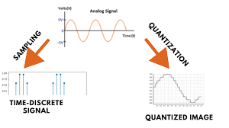

**Quantization**

Quantization is a fundamental step in digital image processing that follows image sampling. After an image is sampled to convert it from a continuous analog form into a discrete digital representation, quantization assigns specific digital values (intensity levels) to each pixel based on its sampled intensity value. In other words, quantization involves approximating the continuous range of intensity values in the original image with a finite set of discrete values.

The primary goal of quantization is to represent the continuous intensity levels of the image with a limited number of bits (or levels) to reduce the amount of data needed for storage and processing. The quantization process is commonly used in digital image compression to reduce the file size while minimizing the loss of visual quality.

The process of quantization can be illustrated using grayscale images as an example. In a grayscale image, each pixel has an intensity value that corresponds to its brightness level. In a typical 8-bit grayscale image, there are 256 intensity levels ranging from 0 (black) to 255 (white).

**During quantization**, the continuous range of intensity values is divided into discrete intervals, and each pixel's intensity is rounded to the nearest value within that interval. For example, if we have 8-bit quantization, the intensity values might be quantized into the following intervals: 0-31, 32-63, 64-95, and so on, up to 224-255.

Any intensity value falling within a particular interval is then assigned the representative value of that interval. This process results in a reduction of the amount of data needed to represent the image. However, it can also lead to a loss of fine details and result in a phenomenon known as quantization error. Quantization error occurs when the original continuous values cannot be perfectly represented by the limited number of discrete levels, leading to some loss of image fidelity.

**The** number of intensity levels used in quantization, also known as the bit depth, determines the quality of the image representation. For example, an 8-bit image has 256 intensity levels, while a 12-bit image has 4,096 intensity levels, offering higher precision and better image quality but also requiring more storage space.

**Resolution**

Resolution, in the context of digital images, refers to the level of detail or clarity present in an image. It is a measure of the number of pixels or dots per unit of length in the image, indicating how finely the image is sampled and displayed. In general, higher resolution images have more pixels and provide greater detail, while lower resolution images have fewer pixels and may appear more coarse or pixelated.

Resolution is commonly expressed using two main measurements:

1. **Spatial Resolution**: Spatial resolution refers to the number of pixels in the horizontal and vertical dimensions of an image. It is often denoted as "width x height" or "horizontal pixels x vertical pixels." For example, a resolution of 1920x1080 (or simply "1080p") represents an image with 1920 pixels in width and 1080 pixels in height. The total number of pixels in such an image would be 1920 x 1080 = 2,073,600 pixels.

Higher spatial resolution results in more detail and sharper images, which is especially important in applications such as photography, digital displays, and video content.

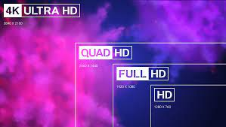

1. **Pixel Density:** Pixel density, also known as dots per inch (DPI) or pixels per inch (PPI), refers to the number of pixels per unit of length in the image. It indicates how closely packed the pixels are within a given physical area of the image. Higher pixel density means more pixels are squeezed into a smaller area, resulting in finer detail.

Pixel density is particularly relevant for printing and display devices, where it determines the quality of the printed output or the sharpness of the displayed content. For example, a higher PPI in a smartphone screen will generally lead to a clearer and more detailed display.

It's important to note that increasing resolution by simply interpolating existing pixels does not add true detail to the image. This process, known as upsampling, may result in larger file sizes but does not improve image quality significantly. In contrast, decreasing the resolution by removing pixels (downsampling) will lead to a loss of detail and may result in a degraded image.

**Elements of image processing system**

An image processing system consists of several interconnected elements that work together to process digital images. These elements enable the system to acquire, manipulate, and analyze images efficiently. The key elements of an image processing system include:

1. **Image Acquisition Devices:** These devices are responsible for capturing or acquiring images from the real world. Examples of image acquisition devices include digital cameras, scanners, and satellite sensors. The quality and capabilities of these devices directly impact the overall performance of the image processing system.
2. **Image Pre-processing Module:** The pre-processing module performs initial operations on the acquired image to prepare it for further analysis. Pre-processing tasks include noise reduction, image denoising, color correction, and contrast stretching. This step helps to enhance the quality of the image and remove any imperfections or distortions.
3. **Image Sampling and Quantization:** Image sampling converts the continuous analog image into a discrete digital representation by selecting specific points (pixels) from the continuous image domain. After sampling, quantization assigns digital values (intensity levels) to each pixel based on its sampled intensity value, effectively reducing the continuous range of intensity values to a finite set of discrete values.
4. **Image Enhancement Module:** Image enhancement techniques are applied to improve the visual quality of the image or highlight specific features of interest. Enhancement methods include contrast stretching, histogram equalization, and spatial filtering. This module helps to make the image more visually appealing or suitable for specific applications.
5. **Image Compression Module:** Image compression reduces the size of the image to save storage space and facilitate efficient transmission over networks. Compression can be lossless (where no image information is lost) or lossy (where some information is discarded to achieve higher compression ratios).
6. **Image Transformation Module:** Image transformation converts images into different domains to reveal specific information or features. For example, the Fourier transform can be used for frequency domain analysis, and the wavelet transform can capture both frequency and spatial information.
7. **Image Segmentation Module:** Image segmentation divides an image into meaningful regions or objects, facilitating object recognition and analysis. This module is essential for tasks such as object tracking, medical image analysis, and scene understanding.
8. **Object Detection and Recognition Module:** This module identifies specific objects or patterns within an image. Object detection and recognition are used in applications like facial recognition, object tracking, and autonomous vehicles.
9. **Image Analysis and Interpretation Module:** This module extracts meaningful information from the processed image, interprets the results, and makes decisions based on the analysis. Image analysis can involve pattern recognition, feature extraction, and classification algorithms.
10. **Display and Visualization Module:** The final step involves displaying the processed image or its results in a visually understandable format for human interpretation and interaction. This module allows users to visualize and interact with the image processing results effectively.

**Applications of Digital image processing**

Digital image processing has numerous applications across various fields due to its ability to analyze, manipulate, and enhance images in a digital format. Some of the key applications of digital image processing include:

1. **Medical Imaging:** Image processing is extensively used in medical applications for diagnosis, treatment planning, and research. It plays a vital role in medical imaging modalities such as X-rays, computed tomography (CT), magnetic resonance imaging (MRI), ultrasound, and positron emission tomography (PET). Image processing techniques aid in detecting tumors, identifying abnormalities, and assisting in surgical planning.
2. **Remote Sensing**: Remote sensing involves acquiring information about the Earth's surface from sensors on satellites and aircraft. Image processing is used to analyze satellite and aerial images for environmental monitoring, land-use classification, urban planning, and natural disaster assessment.
3. **Biometrics:** Image processing is employed in biometric systems for face recognition, fingerprint identification, iris scanning, and other methods of human identification and authentication.
4. **Robotics and Autonomous Vehicles:** Image processing enables robots and autonomous vehicles to perceive and interact with their environment. It is essential for tasks such as object detection, obstacle avoidance, and visual localization.
5. **Entertainment and Multimedia:** Digital image processing is widely used in the entertainment industry for special effects in movies, video games, and virtual reality experiences. It also includes image and video compression for efficient storage and transmission of multimedia content.
6. **Security and Surveillance:** Image processing is utilized in security and surveillance systems for detecting and tracking objects, recognizing faces, and analyzing suspicious activities.
7. **Document Analysis and OCR:** Optical character recognition (OCR) is a type of image processing used to extract text from images or scanned documents, making it searchable and editable.
8. **Image and Video Compression**: Image and video compression techniques are applied to reduce the size of images and videos, allowing efficient storage and transmission in various applications, including web browsing and video streaming.
9. **Digital Photography:** Image processing is a fundamental part of modern digital cameras and smartphones, enabling features like image stabilization, auto-focus, and high dynamic range (HDR) imaging.
10. **Artificial Intelligence and Computer Vision:** Image processing is an essential component of computer vision, which enables machines to understand and interpret visual information. It is used in object recognition, image classification, and image-based machine learning tasks.
11. **Quality Inspection and Manufacturing:** Image processing is used in industrial applications for quality control and inspection in manufacturing processes, such as defect detection in products and character recognition on assembly lines.

These applications highlight the broad and diverse impact of digital image processing in various fields, and its continued development is driving innovation and advancements in technology and industries worldwide.

**Color fundamentals**

Color fundamentals are the basic principles and concepts that govern the perception, representation, and understanding of colors. These fundamentals form the basis for color theory, color models, and color management in various fields, including art, design, computer graphics, and digital imaging. Here are some key color fundamentals:

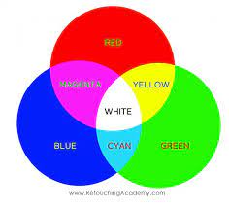

1. **Additive and Subtractive Color Mixing:** There are two primary methods of mixing colors: additive and subtractive. Additive color mixing occurs when colored light is combined, such as on a computer or television screen. When all colors are combined in equal intensity, they result in white light. In contrast, subtractive color mixing involves combining colored pigments, as in the case of mixing paints or in printing. When all colors are combined, they result in black.
2. **Color Perception and Human Vision:** Color is a perceptual phenomenon that results from the response of the human visual system to different wavelengths of light. The human eye contains three types of color receptors, called cones, which are sensitive to red, green, and blue wavelengths. The brain processes the signals from these cones to create our perception of colors.
3. **Color Models:** Color models are mathematical representations used to define and describe colors. The most common color models are RGB (Red, Green, Blue), CMYK (Cyan, Magenta, Yellow, Black), and HSL/HSV (Hue, Saturation, Lightness/Value). Each model serves specific purposes in various applications, such as digital imaging, printing, and color reproduction.
4. **Color Spaces:** Color spaces are specific implementations of color models. They define the range and gamut of colors that can be represented within a particular system. Common color spaces include sRGB, Adobe RGB, and CIE XYZ. Each color space has different color primaries and white points, which affect color accuracy and reproduction.
5. **Color Mixing and Color Gamut**: Color mixing refers to the process of combining different colors to create new colors. The gamut of a color space represents the range of colors that can be produced or reproduced within that space. The size of the gamut varies between color spaces, and some color spaces can represent a broader range of colors than others.
6. **Color Temperature:** Color temperature refers to the perceived warmth or coolness of a light source. It is measured in degrees Kelvin (K). Higher color temperatures, such as daylight (around 6500K), are perceived as cooler and bluer, while lower color temperatures, such as candlelight (around 1800K), are perceived as warmer and more yellow or orange.
7. **Color Harmony**: Color harmony is the pleasing arrangement of colors in a design or composition. It involves understanding how colors interact, complement, and contrast with each other to create a visually appealing result.
8. **Color Vision Deficiencies:** Color vision deficiencies, commonly known as color blindness, are conditions where individuals have difficulty distinguishing certain colors. The most common form is red-green color blindness. Designers and developers need to consider color accessibility to ensure that content is perceivable by users with various color vision abilities.

**Color image formats and conversion**

Color Image Formats:

Color images are represented in various formats to store and display the color information of pixels. Some common color image formats include:

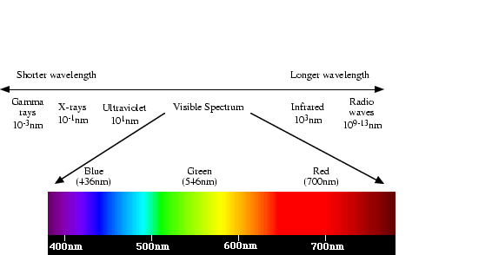

1. **RGB (Red, Green, Blue):** The RGB format represents color using three channels: red, green, and blue. Each channel is represented by an 8-bit value (0 to 255), indicating the intensity of the respective color. Combining these three channels allows for the representation of a wide range of colors. RGB is widely used in digital imaging, computer graphics, and display technologies.
2. **CMYK (Cyan, Magenta, Yellow, Black):** CMYK is primarily used for printing purposes. It represents colors using four channels: cyan, magenta, yellow, and black (K for "key"). CMYK is a subtractive color model, meaning it starts with white and subtracts colors to produce the final color. It is commonly used in the printing industry to achieve full-color prints.
3. **HSL/HSV (Hue, Saturation, Lightness/Value):** HSL and HSV are alternative representations of color that separate hue, saturation, and lightness/value components. Hue represents the color's position on the color wheel, saturation controls the intensity or vividness of the color, and lightness/value determines how dark or light the color is. HSL/HSV are often used in graphics applications for color manipulation and adjustments.
4. **Lab (CIELAB):** The Lab color space is designed to be perceptually uniform, meaning that a change of the same amount in any direction is perceived as a similar change in color appearance. It separates the color information into three components: L* for lightness, a* for the green-red axis, and b* for the blue-yellow axis. Lab is used in color science and color management.
5. **Indexed Color:** Indexed color uses a color palette, which is a fixed set of colors, to represent an image. Instead of storing individual RGB values for each pixel, it stores an index value pointing to a color in the palette. Indexed color is commonly used in GIF images, where a limited number of colors are sufficient for simple graphics and animations.

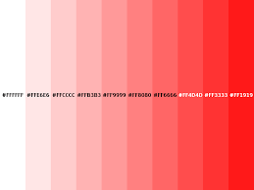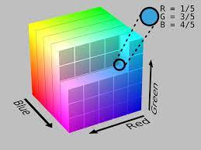

**Color Image Conversion:**

Color image conversion involves changing the representation of color information from one format to another. Some common color image conversions include:

1. **RGB to CMYK:** Converting RGB images to CMYK is necessary when preparing images for print. The conversion involves transforming RGB values to corresponding CMYK values. Note that some colors in the RGB gamut may not be achievable in CMYK, leading to color gamut clipping.
2. **RGB to Grayscale:** Converting RGB images to grayscale produces a single-channel image where each pixel's value represents its intensity or brightness. Various methods exist for grayscale conversion, such as taking the average of RGB channels or using weighted combinations.
3. **RGB to HSL/HSV:** Converting RGB images to HSL or HSV allows for easy manipulation of individual color components, such as changing hue, saturation, or lightness/value values.
4. **RGB to Indexed Color:** Converting RGB images to indexed color involves creating a color palette and mapping RGB values to the closest colors in the palette. This reduces the image's size and is commonly used for web graphics or limited-color images.
5. **CMYK to RGB:** Converting CMYK images to RGB is necessary when displaying or processing images intended for digital displays or graphics applications.
6. **Grayscale to RGB:** Converting grayscale images to RGB involves replicating the grayscale value in all three RGB channels, effectively "colorizing" the image.
7. **Color Space Conversion**: Color space conversion involves transforming color values between different color spaces, such as converting from RGB to Lab or vice versa. This is used in color management and color matching applications.